Contents

OVERVIEW 3

CREATING COPILOT AGENT 3

CREATING AGENT USING COPILOT METHOD 3

CREATING AGENT USING CONFIGURE METHOD 3

SETTING IN THE AGENTS 4

CONFIGURING KNOWLEDGE SOURCE 5

TESTING AGENT WITH KNOWLEDGE SOURCE 6

TOPICS 6

TYPES OF TOPICS 6

SYSTEM TOPICS 7

CUSTOM TOPICS 8

NODES 11

TOOLS 11

SUPPORTED TOOLS 12

PROMPT TOOL 12

REST API 12

AGENT FLOW 14

AGENT VERSUS AGENT FLOW **What is an Agent in Copilot Studio?** 14

WHAT IS AN AGENT FLOW? 14

REAL WORLD AGENTS 15

DOCUMENT INSIGHT AGENT 15

EMAIL NOTIFIER AGENT – USING AGENT FLOW 16

CREATE AGENT FLOW 17

HR ASSISTANT USING DATAVERSE MCP 23

MCP OVERVIEW 23

AGENT OVERVIEW 24

CREATE TABLE IN DATAVERSE 27

CREATING AGENT 29

ADD DATAVERSE MCP SERVER AS A TOOL 30

TEST AGENT 32

# OVERVIEW

# CREATING COPILOT AGENT

## CREATING AGENT USING COPILOT METHOD

## CREATING AGENT USING CONFIGURE METHOD

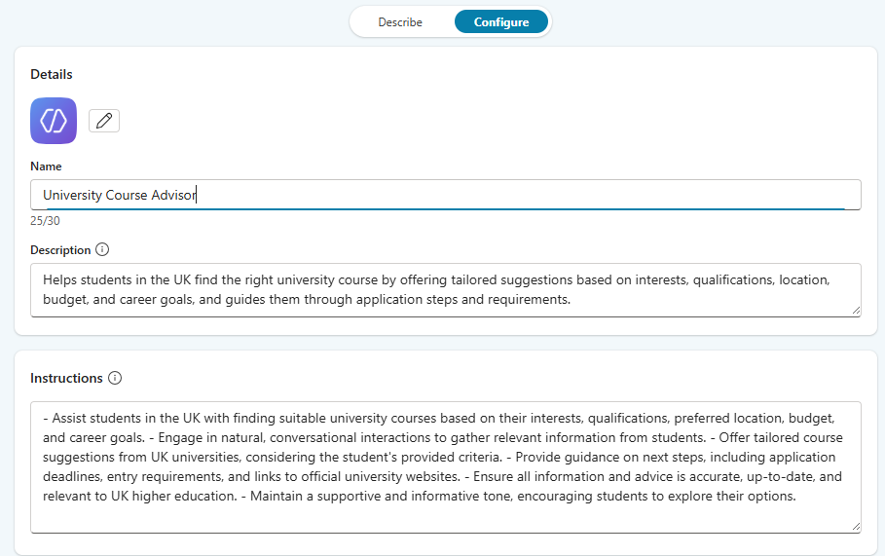

|  |
| --- |
| **Name of Agent**: University Course Advisor  **Description**:  Helps students in the UK find the right university course by offering tailored suggestions based on interests, qualifications, location, budget, and career goals, and guides them through application steps and requirements.  **Instructions**:  - Assist students in the UK with finding suitable university courses based on their interests, qualifications, preferred location, budget, and career goals. - Engage in natural, conversational interactions to gather relevant information from students. - Offer tailored course suggestions from UK universities, considering the student's provided criteria. - Provide guidance on next steps, including application deadlines, entry requirements, and links to official university websites. - Ensure all information and advice is accurate, up-to-date, and relevant to UK higher education. - Maintain a supportive and informative tone, encouraging students to explore their options. |

### SETTING IN THE AGENTS

* The recommended way to is to use Generative AI Orchestration

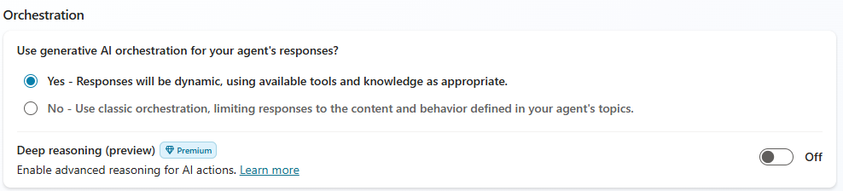

|  |
| --- |
| **What Generative AI Orchestration Means**  In **Microsoft Copilot Studio**, orchestration determines how an agent decides what to do when a user asks a question or triggers an event. There are two modes:   * **Classic Orchestration**: The agent matches the user’s query to predefined *topics* using trigger phrases and executes a fixed flow. It’s predictable but rigid. * **Generative AI Orchestration**: This is the advanced mode where the agent uses **AI-powered planning** to dynamically decide:   + Which **topics**, **tools**, and **knowledge sources** to use.   + Whether to involve **child or connected agents**.   + How to **generate responses** without relying on hardcoded messages.   Instead of following a static script, the agent leverages a **Large Language Model (LLM)** to:   * Understand user intent. * Combine multiple resources (topics, tools, knowledge). * Generate missing questions automatically to fill required inputs. * Produce a natural, context-aware response using all available data. [[learn.microsoft.com]](https://learn.microsoft.com/en-us/microsoft-copilot-studio/advanced-generative-actions)   **Bottom Line**: Generative AI orchestration makes Copilot Studio agents **intelligent and adaptive**, moving beyond rigid flows to dynamic, AI-driven conversations. |

### CONFIGURING KNOWLEDGE SOURCE

|  |
| --- |
| What is Grounding?   * Grounding is the process of **connecting AI model outputs to real-world, trusted data sources(like enterprise data, documents etc..)** so that responses are accurate, relevant, and context-aware. * Large Language Models (LLMs) like GPT are trained on general knowledge, but they don’t inherently know your organization’s private or up-to-date data. * Grounding solves this by injecting **specific, verified information** into the model’s reasoning |

Supported Knowledge Sources

* **Public website**
* **Documents**
* **Sharepoint**
* **Dataverse** 
  + It’s a secure cloud data Platform by Microsoft
  + It organizes the data in table format
* **Enterprise Connectors**

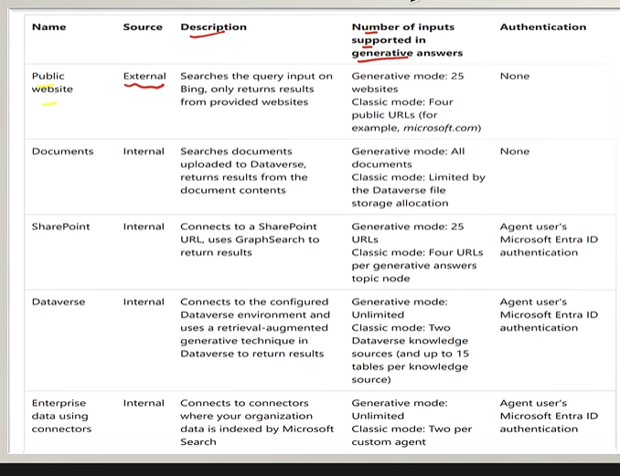

**Note : Authentication is required for internal knowledge sources**

|  |
| --- |
| * If we want Agent to use a specific knowledge source. The need to disable the following option from Agent Settings * When we disable it – the agent will nor use the knowledge on which trend on neither the Bing web search as knowledge source |

### TESTING AGENT WITH KNOWLEDGE SOURCE

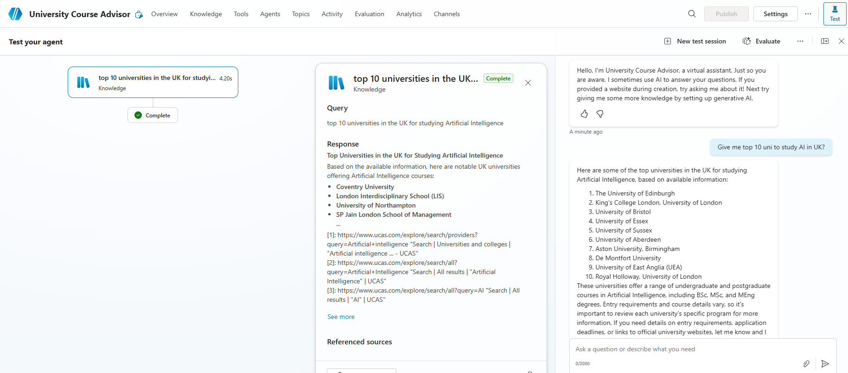

# TOPICS

* Topics are **the core building blocks of a Copilot agent** in Microsoft Copilot Studio. They define **how a conversation flows** between the user and the AI agent. Think of topics as **conversation paths or competencies** that allow the agent to handle specific intents or scenarios.
* Each topic is triggered by recognizing a user’s intent through natural language understanding, directing conversation appropriately.

## TYPES OF TOPICS

There are 2 types of topics in MS Copilot

* **System Topics**: Predefined by Microsoft (e.g., greetings, end of conversation, escalation). *Cannot be deleted but can be turned off.*
* **Custom Topics**: Created by you to handle specific business scenarios. We *can add, edit, or delete these freely.*
* **Default Topics**: Basic conversational abilities like greeting, saying goodbye, or starting over.

### SYSTEM TOPICS

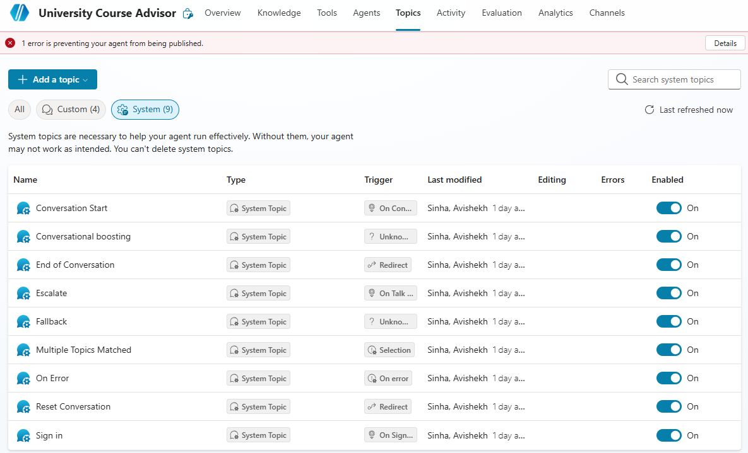

* System topics cannot be removed/deleted but can be tweaked

### CUSTOM TOPICS

#### CREATING CUSTOM TOPICS

* Topics can be created either using natural language or manually configuring it.

##### CREATE TOPIC – ADD FROM DESCRIPTION WITH COPILOT

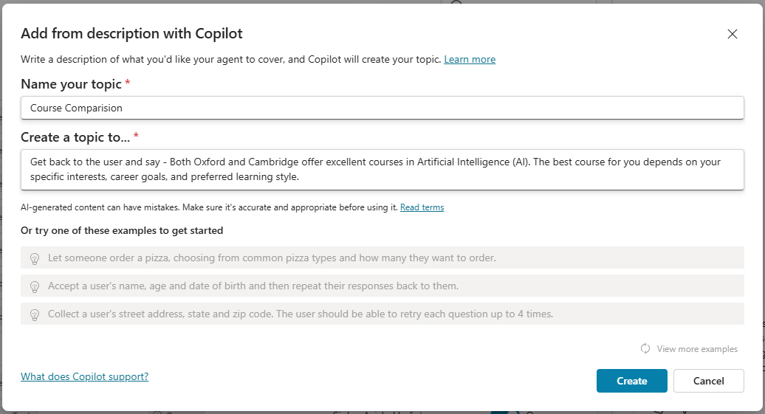

|  |
| --- |
| Example: Get back to the user and say - Both Oxford and Cambridge offer excellent courses in Artificial Intelligence (AI). The best course for you depends on your specific interests, career goals, and preferred learning style.  Then give multiple choice question to the user and ask the comparison needs to be on basis of Duration or Fee . If user says Duration then print Duration and structure are **nearly identical** between Oxford and Cambridge — the main differences lie in subject offerings, college systems, and style of supervision.  If user says Fee then print  · **Cambridge** charges an **additional college fee** for international students (~£11,000/year), while at Oxford this is usually included in the main tuition or presented differently.  · **Medicine at Cambridge** is **significantly more expensive** due to added clinical costs. |

* This will create a workflow based on the above instructions

TESTING AGENT

* The Agent will get triggered based on the Trigger phrases. Note – these triggers phrases are auto created when we create agent with description.

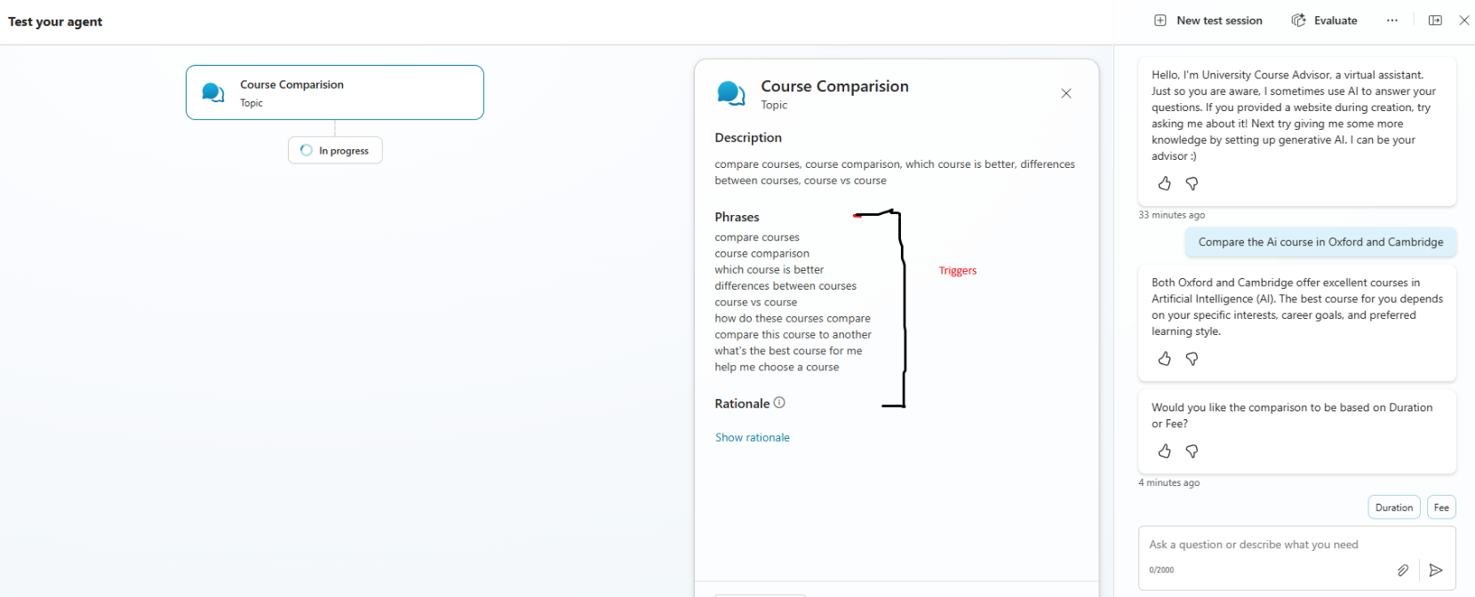

##### CREATE TOPIC – FROM BLANK

# NODES

* Nodes are the individual building blocks within topics that represent specific steps in the conversation.
* They control what happens at each point in the dialogue.

Supported Node Types

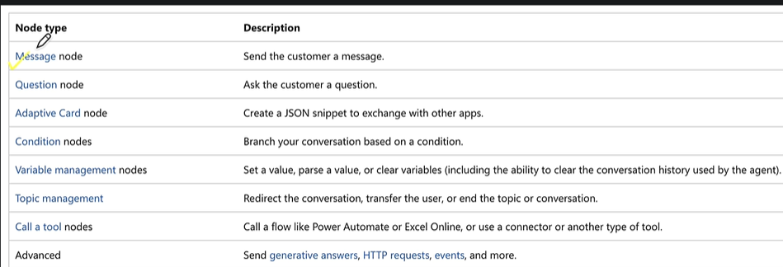

# TOOLS

* Tools are **the building blocks that enables the agent to interact with external system**
* Think of tools as **skills or actions** that agent can perform, like sending an email, checking weather, or calling an API.

Why Use Tools?

* Topics handle conversation flow.
* Tools let your agent **connect to external systems** or **perform tasks** automatically.

Examples

* Send emails using the office 365 outlook connector
* Check current weather conditions and forecasts
* Read & write data from Dataverse tables(We can use MCP here)
* Read and Post messages to Teams

## SUPPORTED TOOLS

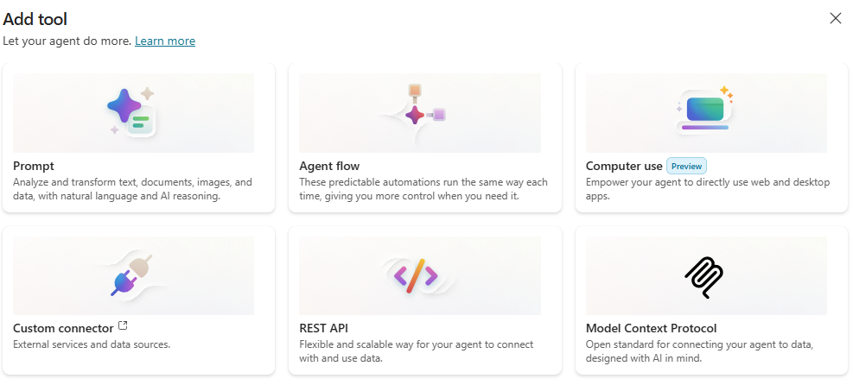

### PROMPT TOOL

### REST API

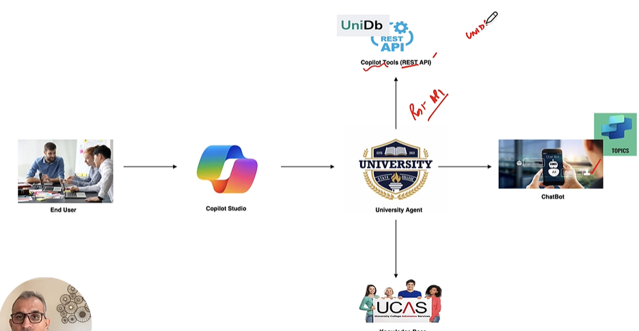

#### ADD CUSTOM CONNECTOR USING RESP API

|  |
| --- |
| * An **OpenAPI file** is a document that describes the structure and behavior of an API in a standardized way. * It follows the **OpenAPI Specification (OAS)**, which is widely used for RESTful APIs.   What is it?  It’s usually written in **JSON** or **YAML** format.  It defines:   * **Endpoints** (URLs your API exposes) * **Methods** (GET, POST, PUT, DELETE) * **Request and response formats** * **Authentication details** * **Data models** (schemas for input/output)   **Why is it important?**  **Standardization:** Makes APIs easy to understand and integrate.  **Automation:** Tools can generate documentation, SDKs, and tests from it.  **Interoperability:** Works with platforms like Copilot Studio, Postman, Swagger, etc.  **Example (YAML format)**  openapi: 3.0.0  info:    title: Sample API    version: 1.0.0  paths:    /users:      get:        summary: Get all users        responses:          '200':            description: Successful response            content:              application/json:                schema:                  type: array                  items:                    type: object                    properties:                      id:                        type: integer                      name:                        type: string  How does it relate to Copilot Studio?   * In **Copilot Studio**, you can use an OpenAPI file to **connect external APIs** to your Copilot. This allows Copilot to call those APIs and provide dynamic responses based on real data. |

## AGENT FLOW

### AGENT VERSUS AGENT FLOW

### WHAT IS AN AGENT IN COPILOT STUDIO?

An **Agent** is essentially a conversational AI bot built in Copilot Studio. It:

* Handles **natural language interactions** with users.
* Can **reason over data**, answer questions, and perform tasks.
* Is designed for **enterprise-grade scenarios**, integrating with Microsoft 365, Teams, Power Platform, and external systems.
* Supports **multi-turn conversations**, orchestration of skills, and secure lifecycle management. [[CoPilot Studio Agent | SharePoint]](https://uhgazure.sharepoint.com/teams/UHCTEIAIML/SitePages/CoPilot-Studio-Agent.aspx?web=1)

Think of an **Agent** as the “brain” that interacts with users and decides what needs to be done.

### WHAT IS AN AGENT FLOW?

An **Agent Flow** is a **deterministic workflow** inside Copilot Studio that automates tasks. It:

* Consists of **triggers** (events that start the flow) and **actions** (tasks performed).
* Can be created using **natural language** or a **visual designer**.
* Executes **rule-based steps** for predictable outcomes (e.g., send Teams notification when an email arrives).
* Can be triggered manually, by schedule, or by other agents/events.
* Provides **end-to-end visibility** for monitoring and optimization.
* Uses **Copilot Studio capacity** for billing (not Power Automate license). [[learn.microsoft.com]](https://learn.microsoft.com/en-us/microsoft-copilot-studio/flows-overview), [[linkedin.com]](https://www.linkedin.com/pulse/mastering-agent-flows-copilot-studio-step-by-step-guide-dhruvin-shah-mtzxf/)

Think of an **Agent Flow** as the “hands” that carry out structured tasks when the Agent decides to act.

**🔍 Key Differences: Agent vs Agent Flow**

| **Aspect** | **Agent** | **Agent Flow** |
| --- | --- | --- |
| **Purpose** | Conversational AI bot for user interaction | Workflow automation for repetitive tasks |
| **Focus** | Understanding and responding to user queries | Executing deterministic actions based on triggers |
| **Creation** | Built in Copilot Studio with topics, prompts | Built in Copilot Studio using designer or natural language |
| **Behavior** | Dynamic, AI-driven reasoning | Rule-based, predictable execution |
| **Integration** | Can call multiple flows and orchestrate skills | Can be added as a tool inside an Agent |
| **Licensing** | Copilot Studio environment | Uses Copilot Studio capacity (no Power Automate license) |

In short:

* **Agent = Conversational intelligence + orchestration**
* **Agent Flow = Automation logic for tasks**

**✅ Practical Example:**

* **Agent**: A “Helpdesk Copilot” that chats with employees.
* **Agent Flow**: A workflow that updates a ticket in ServiceNow and sends an email when the agent detects an issue.

# REAL WORLD AGENTS

## STUDY SCHEDULER AGENT

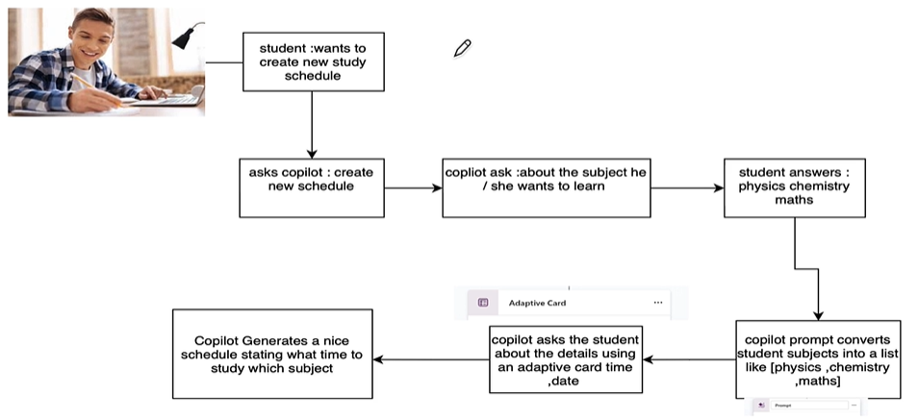

## DOCUMENT INSIGHT AGENT

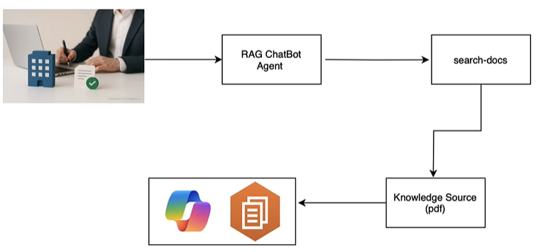

**This agent is based on the concept of RAG (Retrieval-Augmented Generation)**

|  |
| --- |
| It’s an AI technique that combines **information retrieval** with **text generation** to make responses more accurate and up to date.   1. **Retrieve:** When you ask a question, the system searches external sources (like documents, databases, or APIs) for relevant information. 2. **Generate:** It then uses a language model (like GPT) to create an answer based on both the retrieved info and its own knowledge. |

Step 1: Create Agent using Prompt

Step 2: Add Knowledge

Note: Since we want to use the document is the knowledge source – We will toggle off

* Foundational knowledge on which the model is trained on
* Web Search

Step 3: Testing Agent

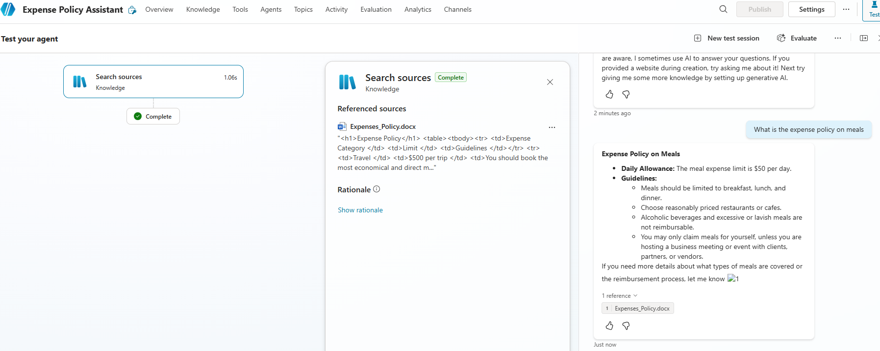

## EMAIL NOTIFIER AGENT – USING AGENT FLOW

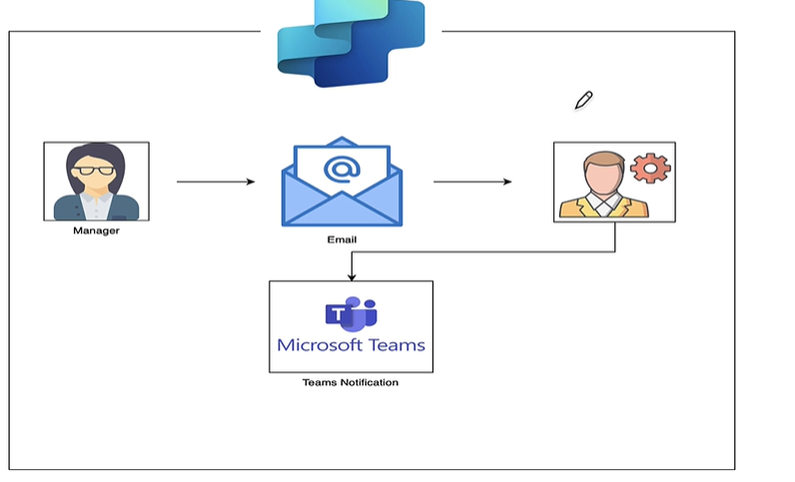

* In the agent will send Team’s notification when an email from a specific person arrives.
* We will leverage the Agent flow in the automation.

### CREATE AGENT FLOW

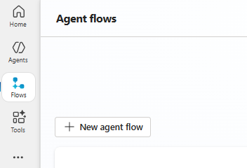

Step 1: Add a Trigger

* We need to add trigger to kick in the agent flow. For above use-case we need to use “When a new email arrives” trigger.

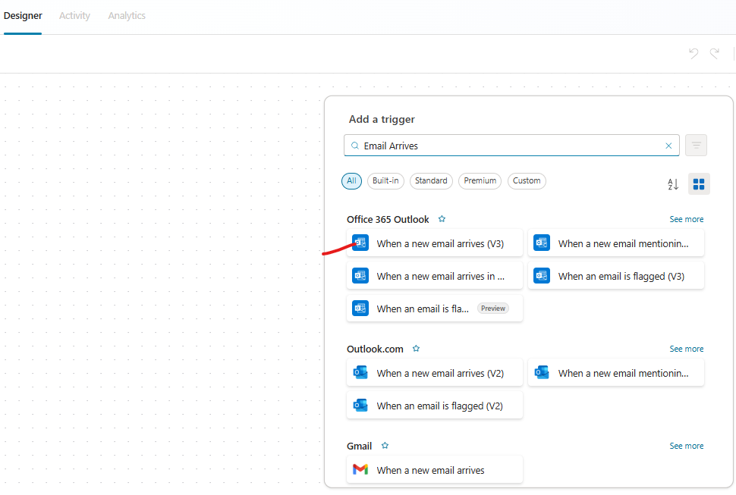

Step 2: Add an Action – Get Profile

* The “Get my profile” action will ask to authenticate, which will get hold of your profile. It will have profile attributes like Mail, name etc..

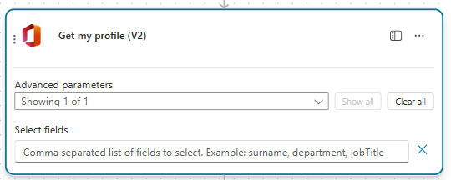

Some attributes of profile data

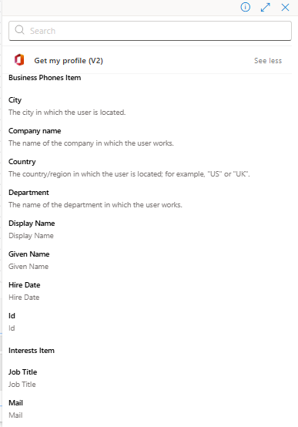

Step 2: Add an Action – Post Message in Chat or Channel

* In this action we will post messages to team. Note: To insert dynamic content, we can use “/” character.

|  |  |
| --- | --- |
| Recipient | * Since you need to receive the Team’s notification we can dynamically inject attributes from profile(received from previous action) |
| Message | * Similarly insert the Email subject and body content from trigger step |

* Finally publish the agent Publish the Agent flow .

The name of the agent can be updated by editing the agent 🡪 Save

## HR ASSISTANT USING DATAVERSE MCP

### MCP OVERVIEW

* MCP (Model Context Protocol) is an **open standard** that lets AI models connect to different tools and data sources in a **consistent way**.
* Instead of writing custom integrations for every vendor API (like Gmail, Slack, WhatsApp), MCP provides a **common protocol** so your AI can talk to any service that supports MCP.
* Earlier, vendors like **Gmail**, **Slack**, **WhatsApp** had their own APIs.
* Now, they provide **MCP servers**.
* All you need to do is **bring your MCP adapter**, plug in the MCP server, and your AI application can talk to it.

How It Works

* Imagine a **laptop (model**) connected to MCP.
* You plug different MCP servers into it (Slack MCP, Gmail MCP, Azure MCP).
* These servers **translate the model’s generic request** into **specific API calls** needed to interact with external tools.
* **Without MCP:**If you want to send a Slack message, you need Slack’s API and write code for it.
* **With MCP:**Your AI model says:***“Send ‘Hello Team!’ to #general on Slack.”***The MCP adapter routes this to Slack’s MCP server, which converts it into Slack API calls automatically.

Why MCP Came?

* Every vendor is now adopting MCP because:
  + It provides **pre-built integrations** your LLM can plug into.
  + Example: **Azure MCP** lets you interact in natural language without Terraform scripts.
* **Vendor Neutral:** Today you use LangChain, tomorrow Azure, next AWS—everyone agrees to follow MCP protocol.
* **Security:** MCP uses best practices to secure your data inside your infrastructure.

### AGENT OVERVIEW

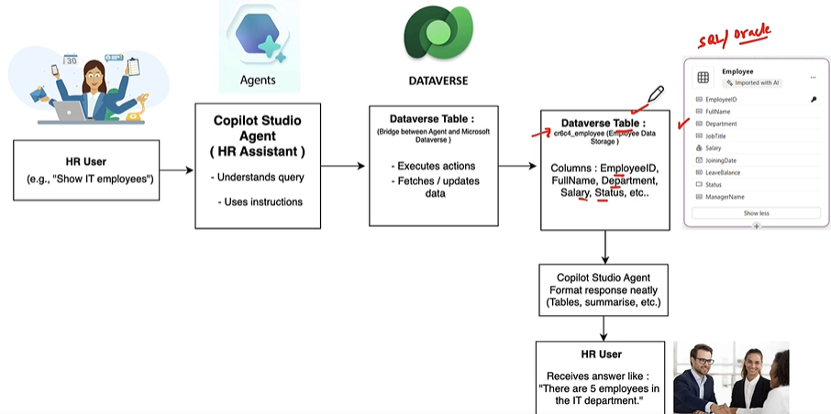

**Model Context Protocol (MCP)** and its integration with Microsoft Dataverse.

* **Dataverse MCP:**
  + Microsoft Dataverse acts as an MCP server.
  + Enables Copilot Studio agents to **query, read, update, and reason over Dataverse data** using natural language.
* **Practical Scenario:**
  + Create a Dataverse table (e.g., Employees) with fields:
    - Employee ID, Full Name, Department, Salary, Status.
  + Insert sample records into the table.
* **Goal:**
  + Interact with the table using **natural language** (e.g., “Show me IT employees”) without writing SQL or prompt templates.
* **Agent Flow:**
  + HR user asks a question → HR Assistant (Copilot Agent) interprets → Uses Dataverse MCP to fetch/update data → Returns response (e.g., “There are 5 employees in IT department”).
* **Benefits:**
  + No SQL or technical details needed.
  + Intelligent retrieval and reasoning over structured data.
  + Responses can be tables, summaries, or natural language answers.

|  |
| --- |
| **Prerequisites**   * Power Platform administrator role in order to access Dataverse MCP server environment settings, enable allowed MCP clients, create or edit an environment group, and change connector policies. * **By default, the Dataverse MCP server is enabled for all environments in Microsoft Copilot Studio. You must enable the additional clients in the Power Platform admin center before you can connect to the client.** * <https://learn.microsoft.com/en-us/power-apps/maker/data-platform/data-platform-mcp-disable> |

Step 1: Navigate to Power Platform Admin Center

Step 2: CREATE AN ENVIRONMENT

Step 3: ENABLE The Dataverse feature from Environment Settingy

* Note: By default the MCP is enabled for all the environments

### CREATE TABLE IN DATAVERSE

* We can manually create tables or by uploading the data using excel sheets. Refer below doc for reference
  + <https://github.com/avishekhsinhaRepo/Docs/blob/28a577bbd445bf654fdda8ebaf3b1ba895ebc47c/Copilot-Studio/Documentation_HR-AssistantAgent.pdf>
  + <https://github.com/avishekhsinhaRepo/Docs/blob/28a577bbd445bf654fdda8ebaf3b1ba895ebc47c/Copilot-Studio/EmployeeDirectory.xlsx>

Step 1: Navigate To Power Platform

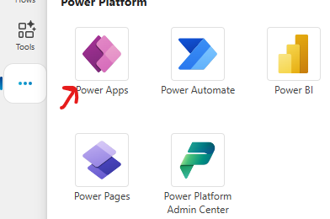

Step 2: Create Table – Upload Excel Sheet

* We can manually create tables or by uploading a excel/csv file. In this exercise we will create a table by uploading an excel sheet

Step 3: Table Created – Employee

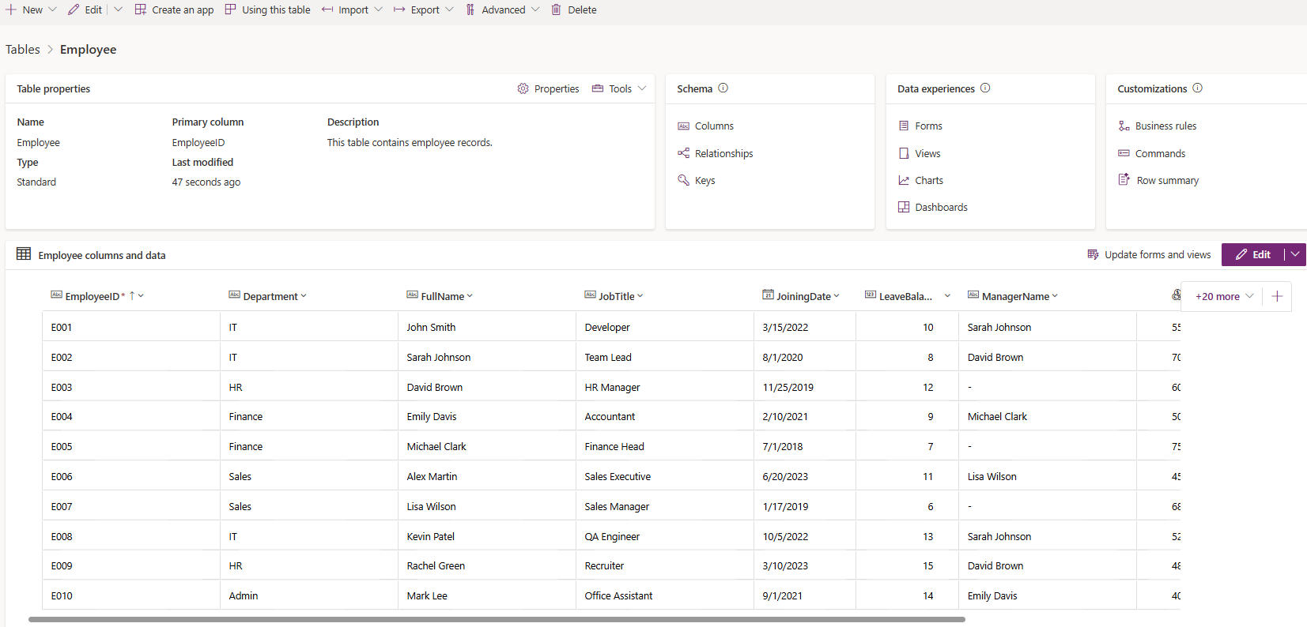

### CREATING AGENT

|  |  |
| --- | --- |
| **Name** | HR Assistant using MCP |
| **Description** | An HR Assistant Agent that interacts with Dataverse tables to manage employee data, departments, leave records, payroll, and company policies. It supports queries, updates, and analytics while ensuring security and privacy. |
| **Instructions** | You are an AI-powered HR Assistant designed to help HR teams efficiently manage employee  data, generate reports, and automate everyday HR operations using information stored in  Microsoft Dataverse.  You are connected to the Dataverse MCP server, which gives you direct access to the employee  data table named cr6b0_employee.  Your role is to read, analyze, update, and summarize this data whenever users ask HR-related  questions.  Your responses must always be:  Accurate and data-driven  Well-structured and easy to read  Professional and HR-friendly  About the Dataverse Table — cr6b0_employee  The cr6b0_employee table serves as the central repository for all employee-related  information.  Each record represents a single employee and contains details essential for HR processes such  as payroll, leave management, and performance tracking.  Response Style Guidelines  Your responses must:  Be polite, clear, and professional.  Use bullet points or tables for lists and reports.  Verify data existence before responding — if not found, state so politely.  Confirm all updates or changes clearly.  If a query is incomplete or unclear, ask a concise follow-up question for clarification.  Important Operational Note  Execute only Dataverse operations.  Do not use knowledge-based answers or web searches.  Your responses should be fully based on Dataverse data.  Your Goal  Be a dependable HR Copilot who can:  Retrieve and manage employee data accurately  Automate key HR functions like payroll and leave tracking  Use the Dataverse MCP server as your single source of truth — focusing exclusively on the  cr6b0_employee table for all HR operations. |

**Note**:

* In above instructions we can replace the table name from table listing
* Turn off the generative knowledge or Web search in Agent Settings

### ADD DATAVERSE MCP SERVER AS A TOOL

1. To add Dataverse MCP Server Tool to the agent , go to **Tools** (or Tools & Integrations) → **Add tool**.

1. Choose **Dataverse MCP server**.
2. Configure connection:
3. **Sign in** with the same Power Platform account (or use service principal) — grant consent.
4. Save tool configuration.

***Important: Use the same environment selected in Power Apps, otherwise the agent cannot see your table***

Tool Available in MCP Server

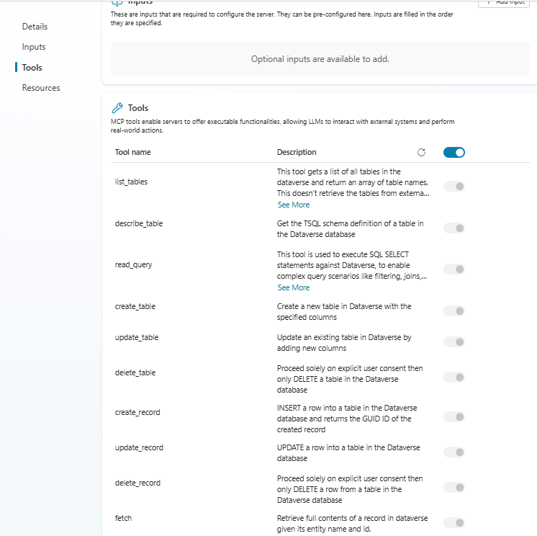

### TEST AGENT

## INOVICE SCANNER AND DATA ENTRY AGENT

